Exploring Spatial Information
and Analysis in Agriculture
Advanced Spatial Analysis Issues

Sponsored by Red Hen Systems, Inc.
2310 East Prospect Road, Fort Collins, CO 80525
Phone: 800-237-4182 Web: www.redhensystems.com
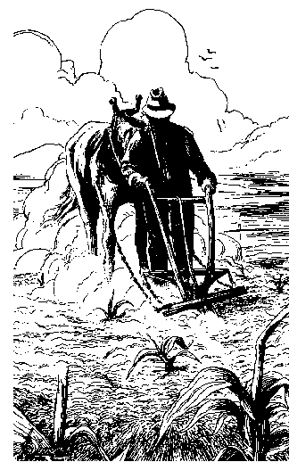
“Site-specific management promises to revolutionize production agriculture, but the underlying science and technology needed to go beyond pretty maps is a work in progress”

Hosted by Dr. Joe Berry and Dr. Carol Snyder
August 17-18, 2000 — Fort Collins Marriott Hotel — Fort Collins, Colorado

Exploring Spatial Information and Analysis in Agriculture

Advanced Spatial Analysis Issues
Sponsored by Red Hen Systems, Inc.

Hosted by Dr. Joe Berry and Dr. Carol Snyder

August 17-18, 2000
The Fort Collins Marriott, 350 East Horsetooth Road, Fort Collins, CO 80525

Thursday, August 17, 2000

8:00am-12:00 pm
- Mapped Data Visualization and Summary
- Preprocessing and Map Normalization
- Comparing Maps and Temporal Analysis

12:00pm-1:00pm, Lunch

1:00pm-4:00pm
- Understanding Spatial Correlation
- Interpolating and Assessing Map Surfaces
- Integrating Remote Sensing Data

5:00pm-7:30pm, Picnic at Lory State Park
- Video Mapping Hike and Scavenger Hunt

Friday, August 18, 2000

8:00am-12:00 pm
- Delineating Management Zones
- Clustering Groups of Similar Data
- Measuring Correlation Among Maps

12:00pm-1:00pm, Lunch

1:00pm-4:00pm

- Developing Predictive Models
- Generating Management Action Maps

4:00pm - ???, Happy Hour and Relaxation in Fort Collins Old Town Historic District

Workshop Resources…

Workbook Materials

Who’s Minding the Farm?
Lecture Notes

CD Materials
Course Syllabus with Interactive Links
The Precision Farming Primer: GIS Technology and Site-Specific
Management in Production Agriculture
Map Analysis: Procedures and Application in GIS Modeling
MapCalc Tutorial Software
Surfer Tutorial Software
tMAP Tutorial Software
MapCalc Description
Surfer Description

Insert self-booting CD into your drive and the following screen will appear…

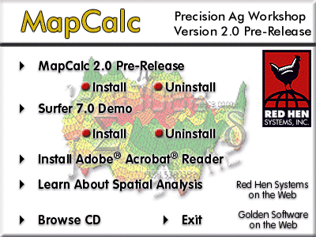
From this screen you can install the MapCalc and Surfer tutorial software, install the Adobe Acrobat Reader, and interactively view workshop resource materials.

To access the workshop resource materials, click on the “Learn About Spatial Analysis” item then follow the hyperlinks in the syllabus for PowerPoint notes, background readings, and exercises. The tMAP Tutorial System can be installed from this location.

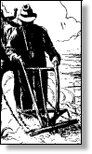
Exploring Spatial Information
and Analysis in Agriculture
Advanced Spatial Analysis Issues

Lecture Notes…

- Map Data Visualization and Summary
- Preprocessing and Map Normalization
- Comparing Maps and Temporal Analysis
- Understanding Spatial Correlation
- Interpolating and Assessing Map Surfaces
- Integrating Remote Sensing Data
- Delineating Management Zones
- Clustering Groups of Similar Data
- Measuring Correlation Among Maps
- Developing Predictive Models
- Generating Management Action Maps

Exploring Spatial Information
and Analysis in Agriculture
Advanced Spatial Analysis Issues

Workshop Exercises…

- Ex#1 Visualizing yield data
- Ex#2 Map normalization
- Ex#3 Assessing localized variation
- Ex#4 Assessing rate of change
- Ex#5 MC display options
- Ex#6 MC macro builder
- Ex#7 Comparing map surfaces
- Ex#8 Spatial interpolation
- Ex#9 Data clustering
- Ex#10 Region- wide summary
- Ex#11 Calculating map correlation
- Ex#12 Exporting MapCalc data
- Ex#13 Micro terrain analysis

A framework for precision farming based on mapped data analysis…

Who’s Minding the Farm?
GIS in Production Agriculture and Site-Specific Management

Joseph K. Berry, GIS World, February 1998

To many, Precision Farming (PF) might appear an oxymoron. With mud up to axles and 400 acres left to plow, precision seems worlds away. Yet site-specific management makes sense to a rapidly growing number of farmers as years of experience confirm the variability in field conditions and yield. Mapping and analyzing field variability and linking spatial relationships to management actions place production agriculture at the cutting edge of GIS applications. Its use down on the farm is both down to earth and down right ambitious.

Underlying Principles
Until the 1990s maps played a minor role in production agriculture. Soil maps and topographic sheets, for the most part, were too generalized for application at the farm level. Acquisition of spatial data with the detail and information farmers needed for operations were beyond reach. The principle of whole-field management, based on broad averages of field data, dominated management actions. Weigh-wagon, or grain elevator measurements established a field’s yield performance. Soil sampling determined the typical nutrient levels within a field. From these and other data the best overall seed variety was chosen and a constant rate of fertilizer applied, as well as a bushel of other decisions—all treating the entire field as uniform within its boundaries.

Site-specific management, on the other hand, recognizes the variability within a field and is about doing the right thing, in the right way, at the right place and time. It involves assessing and reacting to field variability by tailoring management actions, such as fertilization levels, seeding rates and variety selection, to match changing field conditions. It assumes that managing field variability leads to both cost savings and production increases, as well as improved stewardship and environmental benefits.

Unusual Blend of Technologies
Site-specific farming isn’t just a bunch of pretty maps, but a set of new technologies and procedures linking mapped variables to appropriate management actions. It requires the integration of several key elements: the global positioning system (GPS), on-the-fly data collection devices, geographic information systems (GIS) and variable rate implements. Modern GPS receivers are able to establish positions within a field to about a meter. When connected to a data collection device, such as a yield/moisture meter, these data can be “stamped” with geographic coordinates. Several portable “heads-up” digitizing devices allow farmers to sketch conditions, such as weed infestations, on a map or aerial photo backdrop. A GIS is used to map the field data so a farmer can see the conditions throughout a field. The GIS also can be used to extend map visualization of yield to analysis of the relationships among yield variability and field conditions. Once established these relationships are used to derive a “prescription” map of management actions required for each location in a field. The final element, variable rate implements, notes a tractor’s position through GPS, continuously locates it on the prescription map, then varies the application rate of field inputs, such as fertilizer blend or seed spacing, in accordance with the instructions on the prescription map. Combining the technologies of GPS, GIS and IDI (intelligent devices and implements) provides the mechanisms to manage field variability. The maturation and commercialization of these technologies have made the concept practical.

Processing PF Data
To date, most analysis has been visual interpretations of yield maps. By viewing a map, all sorts of potential relationships between yield variability and field conditions spring to mind. These “visceral visions “ and explanations can be drawn through the viewer’s knowledge of the field. More recently, data visualization is being extended through map analysis at three levels: cognitive, analysis and synthesis.

The foundation of precision farming occurs at the cognitive level where desktop mapping is used to manage and store mapped data. At the analysis level map analysis is used to discover relationships among the mapped variables, such as yield and soil nutrient levels. This step is analogous to a farmer’s visceral visions of relationships, but uses the computer to establish more detailed mathematical and statistical connections. Although this step is somewhat an uncomfortable “leap of scientific faith,” it extends data visualization by investigating the coincidence of the patterns of variation among a set of maps. The results relate yield goals to specific levels of farm inputs—traditional agricultural research, but tailored to a farmer’s “backyard.”

The synthesis level evaluates newly derived relationships to formulate management actions for a new location (change in space) or another year at the same place (change in time). The result is a prescription map used to guide the intelligent implements as they “variable rate control” application of field inputs. Or, the analysis might discover an area of abnormally low yield as aligning with a section of old drainage tile in need of repair. Further analysis might locate areas whose simulated yield increases under drier conditions justify installation of additional drainage tiles.

Technical Issues
The precision farming process can be viewed as four steps: data logging, point sampling, data analysis and spatial modeling (see figure). Data logging continuously records measurements, such as crop yield, as a tractor moves through a field. Point sampling, on the other hand, uses a set of dispersed samples to characterize field conditions, such as phosphorous, potassium, and nitrogen levels. The nature of the data derived by the two approaches are radically different— a “direct census” of yield consisting of thousands of on-the fly samples versus a “statistical estimate” of the geographic distribution of soil nutrients based on a handful of soil samples.

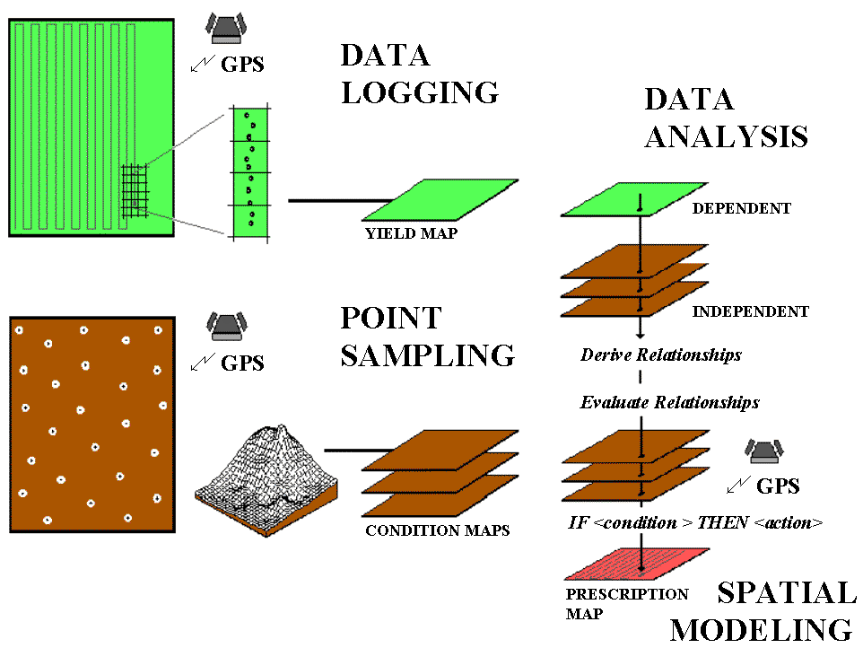
Steps in the Precision Farming Process.

In data logging, issues of accurate measurement, such as GPS positioning and material flow adjustments, are major concerns. Most systems query the GPS and yield monitor every second, which at 4mph translates into about six feet. With differential positioning the coordinates are accurate to about a meter. However the paired yield measurement is for a location well behind the harvester, as it takes several seconds for material to pass from the point of harvest to the yield monitor. To complicate matters, the mass flow and speed of the harvester are constantly changing when different terrain and crop conditions are encountered. The precise placement of GPS/Yield records is not reflected as much in the accuracy of the GPS receiver as in “smart” yield mapping software.

In point sampling, issues of surface modeling (estimating between sample points), such as sampling frequency/pattern and interpolation technique, are of concern. The cost of soil lab analysis dictates “smart sampling” techniques based on terrain and previous data be used to balance spatial variability with a farmer’s budget. In addition, techniques for evaluating alternative interpolation techniques and selecting the “best” map using residual analysis are available in some of the soil mapping systems.

In both data logging and point sampling, the resolution of the analysis grid used to geographically summarize the data is a critical concern. Like a stockbroker’s analysis of financial markets, the fluctuations of individual trades must be “smoothed” to produce useful trends. If the analysis grid is too coarse, information is lost in the aggregation over large grid spaces; if too small, spurious measurement and positioning errors dominate the information.

The technical issues surrounding mapped data analysis involve the validity of applying traditional statistical techniques to spatial data. For example, regression analysis of field plots has been used for years to derive crop production functions, such as corn yield (dependent variable) versus potassium levels (independent variable). In a GIS, you can regress an entire map of corn yield with maps of soil nutrients to derive the production function relating the mapped variables—like analyzing thousands of sample plots. However, technical concerns, such as variable independence and autocorrelation, have yet to be thoroughly investigated. Statistical measures assessing results of the analysis, such as a spatially responsive correlation coefficient, await discovery and acceptance by the statistical community, let alone the farm community.

In theory, spatial modeling moves the derived relationships in space or time to determine the “optimal” actions, such as the blend of phosphorous, potassium and nitrogen to be applied at each location in the field. In current practice, these translations are based on existing science and experience without a direct link to data analysis of on-farm data. For example, a prescription map for fertilization is constructed by noting the existing nutrient levels (condition) then assigning a blend of additional nutrients (action) tailored to each location forming a If <Condition> Then <Action> set of rules. The issues surrounding spatial modeling are similar to data analysis and involve the validity of using traditional “goal seeking” techniques, such as linear programming or genetic modeling, to calculate maps of the optimal actions.

Current Reality and Future Directions
The application of GIS within production agriculture has been rapid. In less than ten years precision farming has moved from inception to operational reality on millions of acres in the U.S. alone. Its current expression emphasizes the generation of yield maps by linking GPS with on-the-fly yield monitors. Valuable insight is gained by visualizing field variability, particularly when yield maps for several years are considered. More advanced applications involve analysis of soil nutrient maps to derive a prescription map used in variable rate control of fertilizer.

The infrastructure for precision farming is coming online. Most manufacturers offer PF options with their farm vehicles and implements. A growing number of service providers offer advice to farmers in their adoption of the new technology. At present, however, a full implementation of precision farming is in the hands of the developers and researchers. Advancements in the data analysis and spatial modeling phases await contributions from the GIS community. The considerable knowledge and methodologies of the agricultural science community need to be reviewed for their spatial inferences. Opportunities abound in one of GIS’s more important applications and we all benefit from precision farming’s fruits—check it out at your local super market.

No part of this workbook may be reproduced, stored in a retrieval system, or transmitted, in any form or by any means, electronic, mechanical, photocopying, recording, or otherwise, without consent of the author. Holders of valid MapCalc Learner-Academic licenses may freely use the materials. Others need to contact Joseph K. Berry, Berry and Associates, 2000 South College Avenue, Suite 300, Fort Collins, Colorado, USA 80525; Phone: 970-215-0825; Email: jberry@innovativegis.com.

